**SAX Practical**

Give the XML document about a list of contacts in file:

<https://cmshn.fpt.edu.vn/pluginfile.php/292828/mod_resource/content/0/contacts.xml>

Write java program with the UI look like figure 1. Let user search contacts with some information.

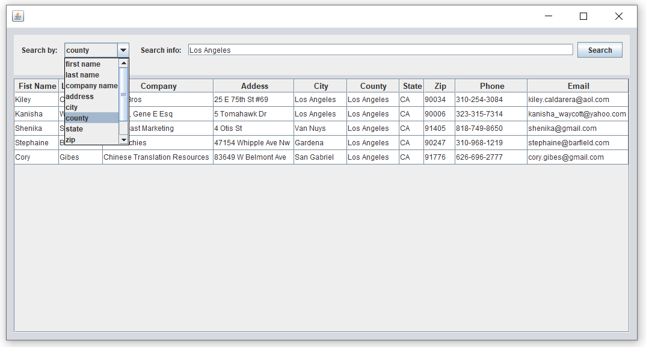

Figure